**OUTPUTS**

**Developing a Backend Admin for Learner’s Academy.**

**1. Login page:**

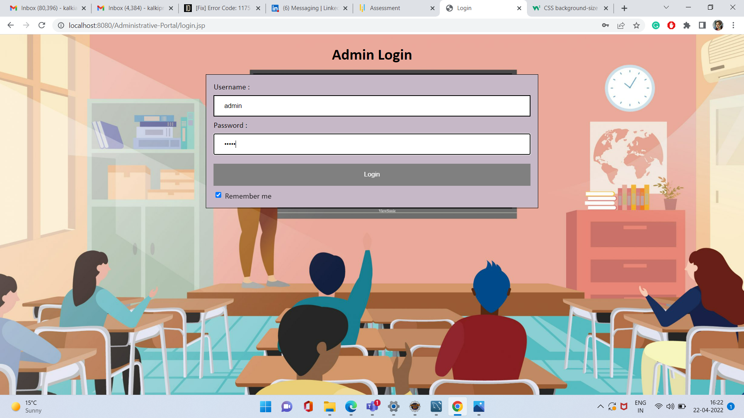

**2. Enter the username and password:**

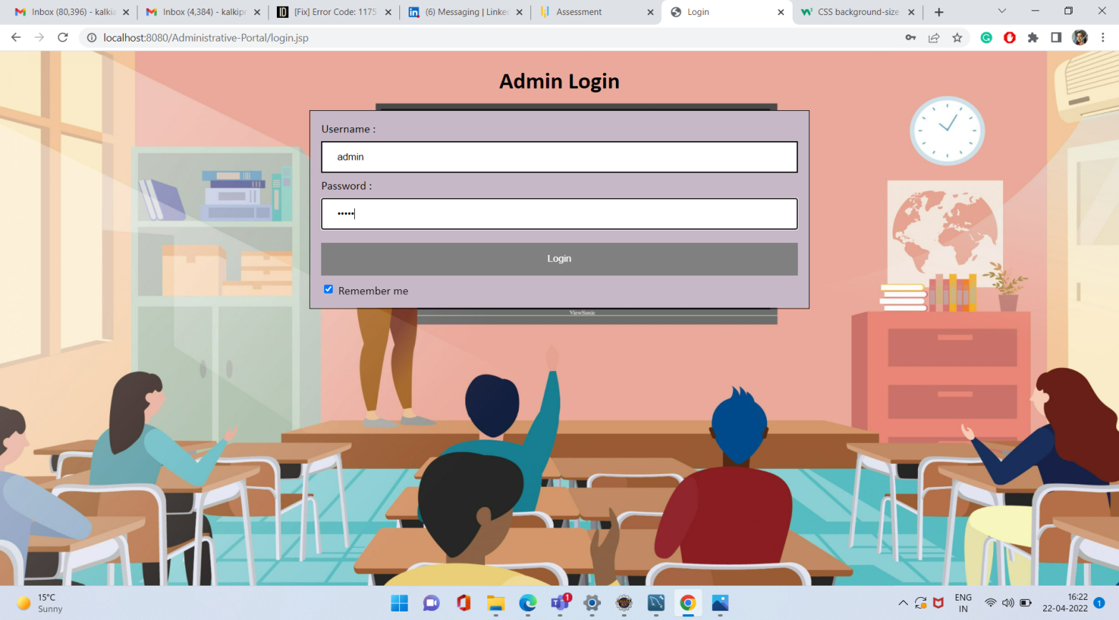

**3. Classes:**

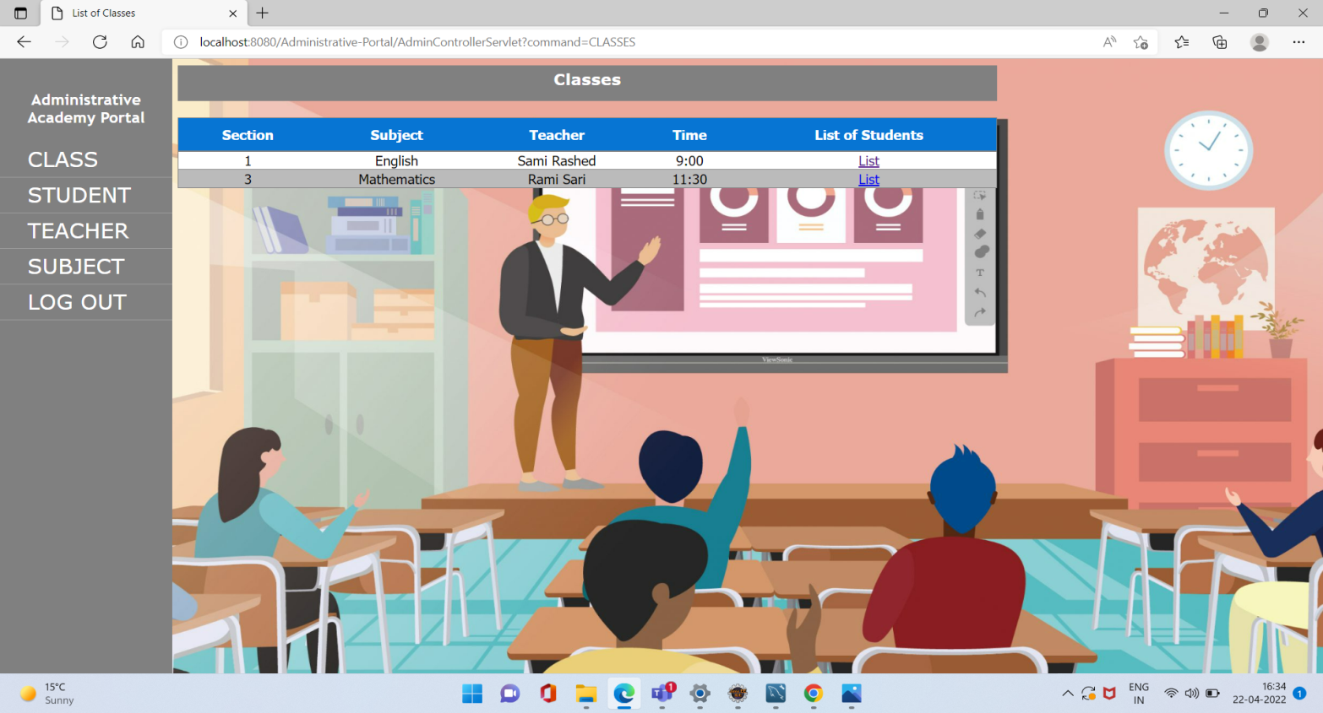

**3.1. List of students in English classes section 1:**

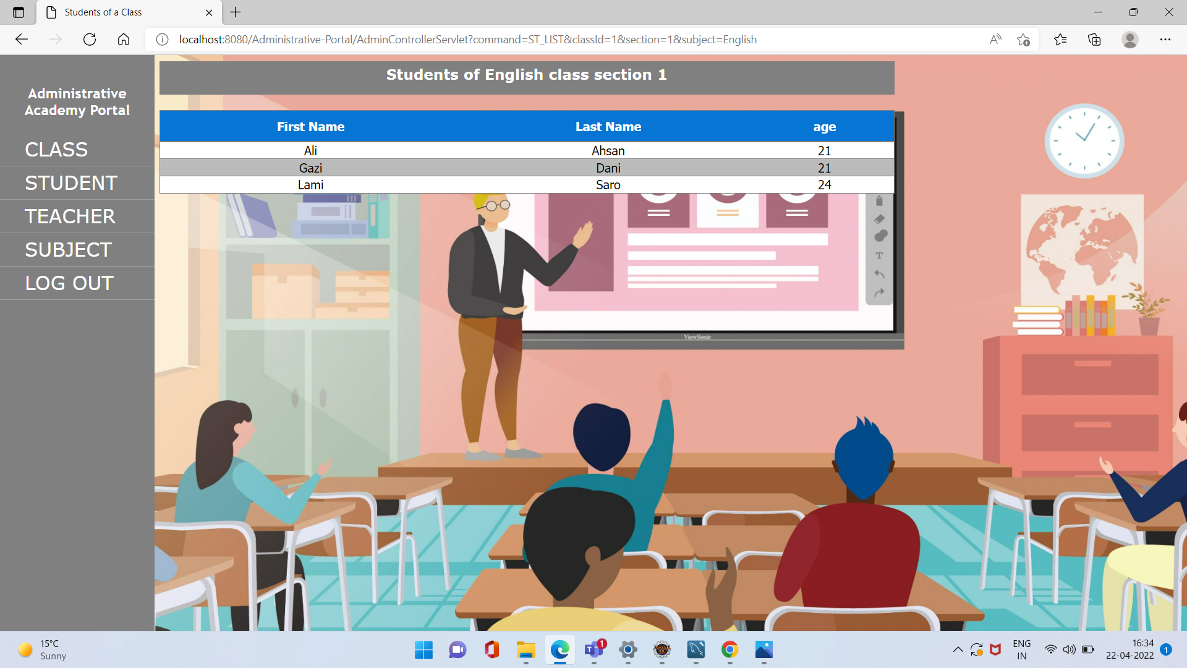

**4. Students:**

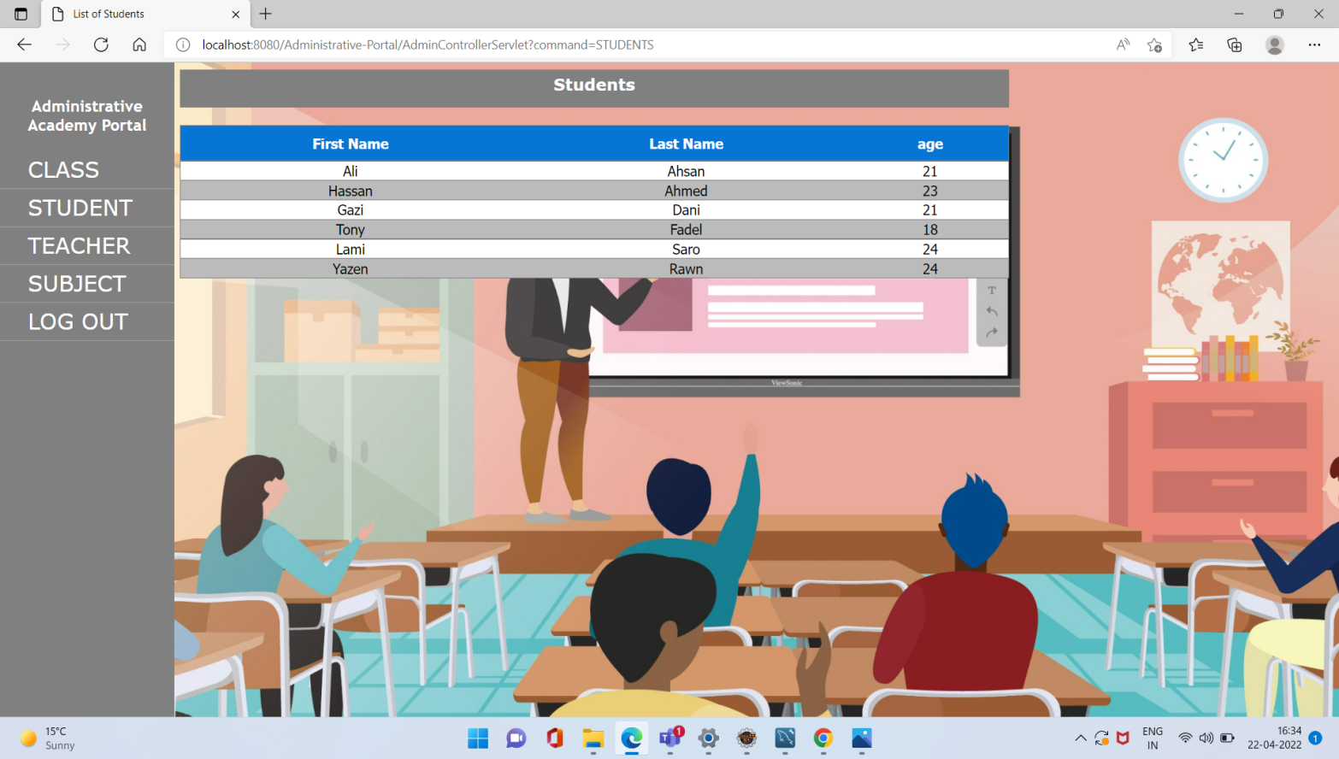

**5. Teachers:**

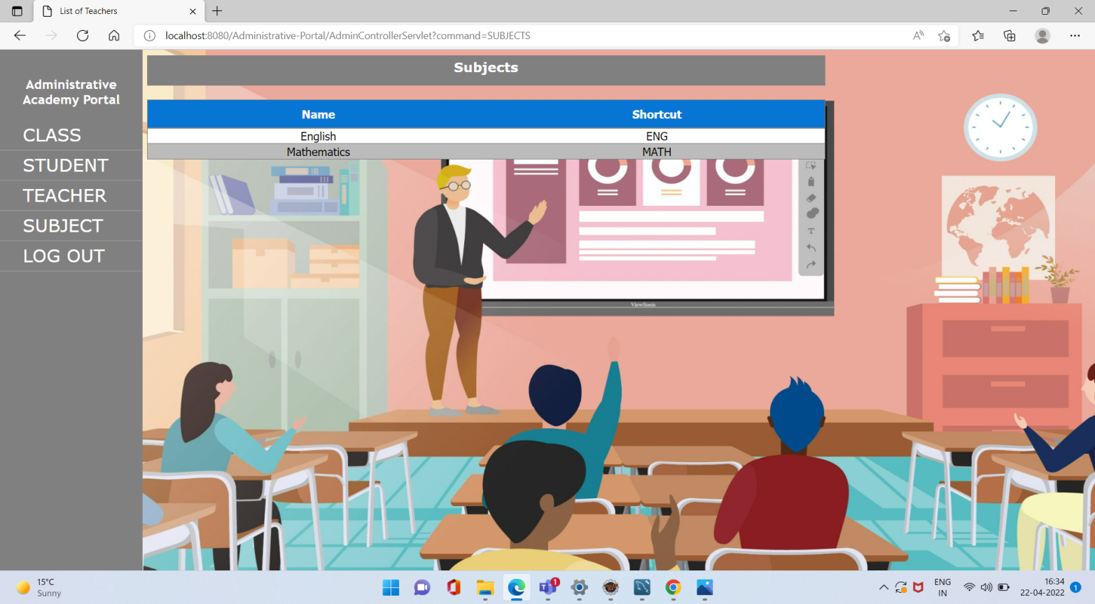

**6. Subjects:**

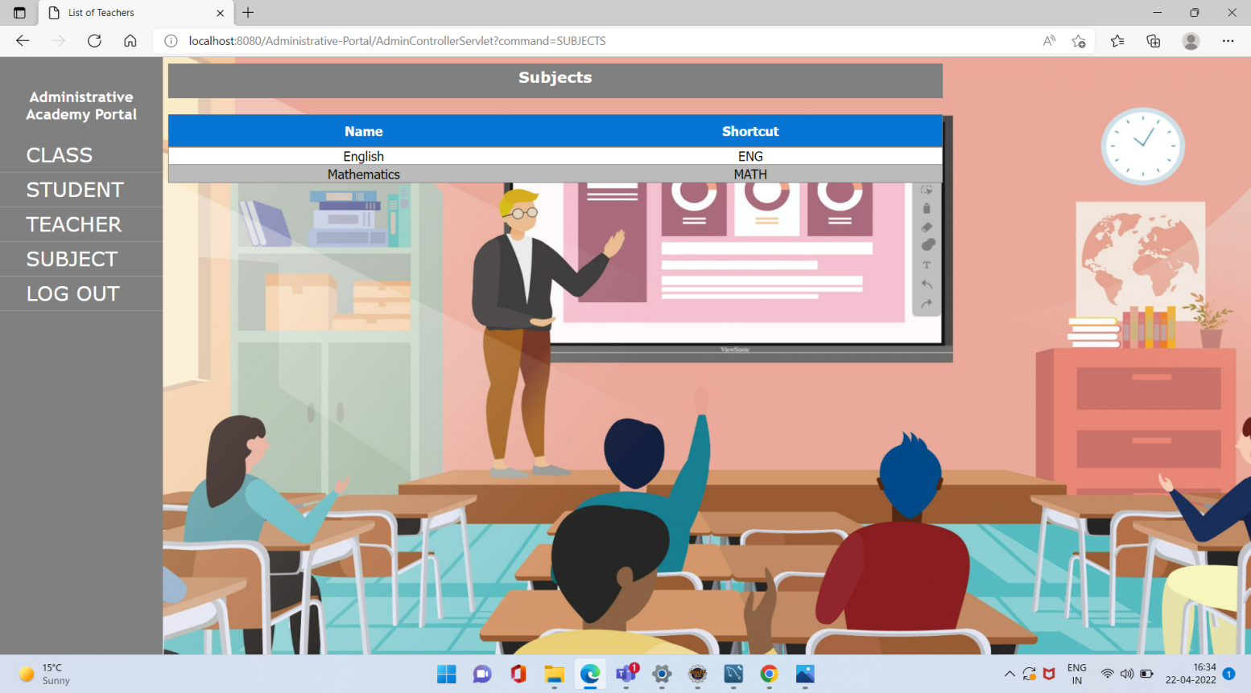

**7. Flow chart:**

